CAS PY 106

Pre-session 7 notes

Electrical Potential

1. Electric potential
2. Electric potential, which is related to potential energy in the same way electric field is related to force

E = F/q

V = U/q or U = qV

Change in V = Change in U/q

1. Electric potential is another way to visualize how a charged object or set of charged objects affects the region around it (in addition to field)
2. Voltage is essentially a difference in electric potential, which changes how charges flow in a way analogous to how pressure differences affect the flow of fluid (if you want charge to flow, have potential difference)
3. Point charges
4. Potential a distance r away from a single point charge of charge q is

V = kq/r

1. When there are multiple point charges, net electric potential at a point is found by adding contributions from each point charge. Potential is scalar, so it is easy to add contributions (add numbers)
2. Sign on potential comes from sign on the charge itself. Positive charges only make positive contributions to net electric potential, and negative charges only make negative contributions to net electric potential
3. 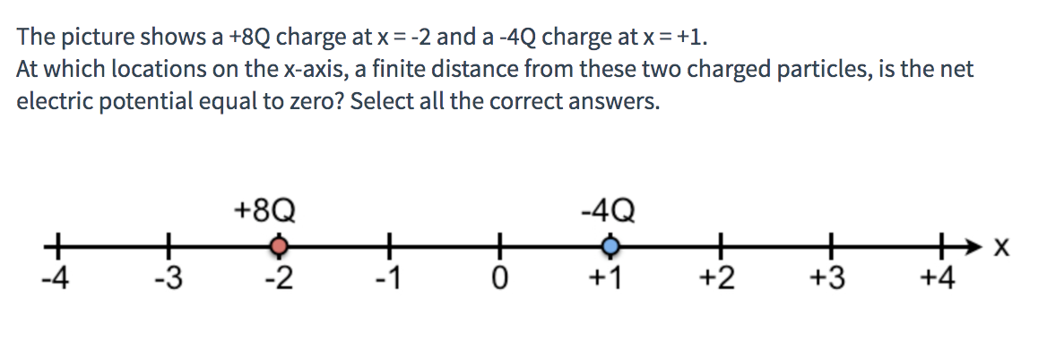

Point 1: between 8Q and -4Q

V= kq/r

0 = k\*8q/r + k\*(-4q)/(3-r)

0 = 8kq/r – 4kq/(3-r)

8kq/r = 4kq/(3-r)

2/r = 1/(3-r)

6-2r =r

3r = 6

r = 2

At x = 0, electric potential = 0

Point 2: Right of -4Q

V= kq/r

0 = k\*8q/(r+3) + k\*(-4q)/r

8kq/(r+3) = 4kq/r

2/(r+3)=1/r

2r = r + 3

r = 3

At x = 4, electric potential = 0

1. Equipotentials in a uniform field
2. 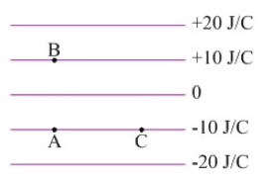
3. Direction of electric field (Down- field points in direction of decreasing potential)

E = -delta V/ delta r

1. The units of J/C are equivalent to volt (J/C = V)
2. 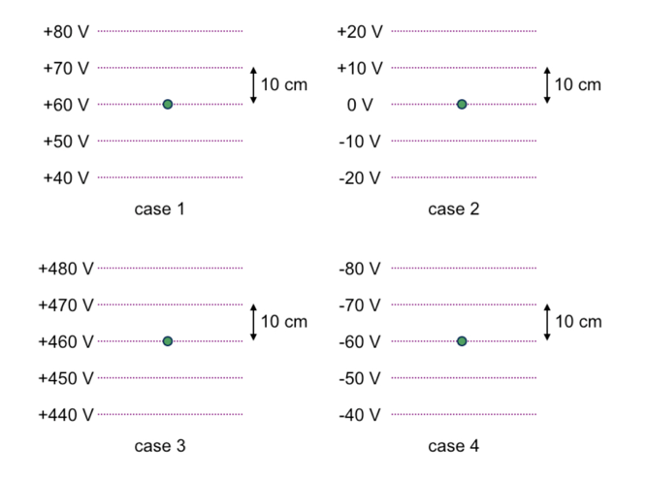
3. Case 1,2,3 have electric fields directing down while case 4 has electric field directing up
4. The magnitude of the electric field is all same
5. Potential difference
6. Potential difference, delta V, is far more important than potential. In uniform electric field,

Delta v = delta U/q = -F\*delta r \* cos(theta)/q = -qE\*delta r \* cos(theta)/q = -E\*delta r \* cos(theta)

Where theta = angle between field ad displacement

When only need the magnitude of potential difference, simplify to delta V = Ed where d is the distance moved parallel to the field

1. Gravitational potential difference
2. Gravitational potential difference 🡪 delta V = delta U/m = mgh/m = gh
3. Potential from a point charge
4. Electric potential set up by point charge is an example of potential when field the field is non-uniform. Note that potential is defined to be zero when r = infinity
5. Electric potential a distance r from a point charge 🡪 V = kq/r
6. 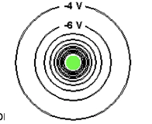
7. Direction of the field 🡪 points in (field points in the direction of decreasing potential)
8. In addition, the pattern of equipotentials is produced by object with negative charge, and electric field points toward a negative charge
9. Moving through the field
10. 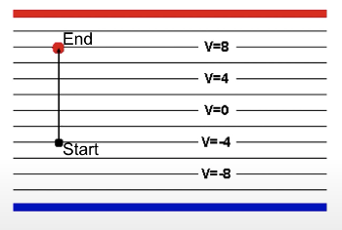
11. +q test charge moved vertically distance r in uniform field. Change in potential experienced by charged is 🡪

delta V = V final – V initial = 8V-(-4V) = 12V

1. Even though the charge is changed to negative charge, change in potential is still 12 V
2. However, potential energy, delta U = q \* delta V, is different in these cases
3. Electric Field and Electric potential
4. Green line represents electric potential
5. Purple line represents electric field
6. Both charges are positive

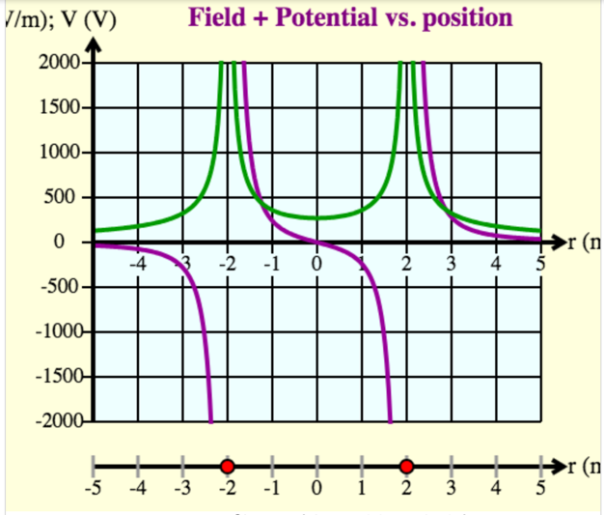

1. Both charges are negative

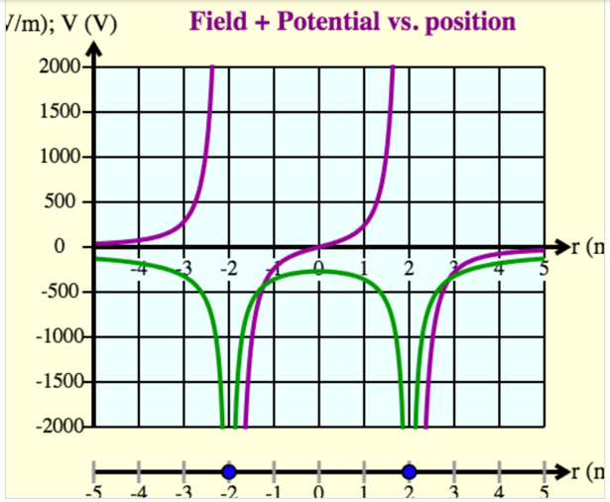

1. Left charge is positive, right charge is negative

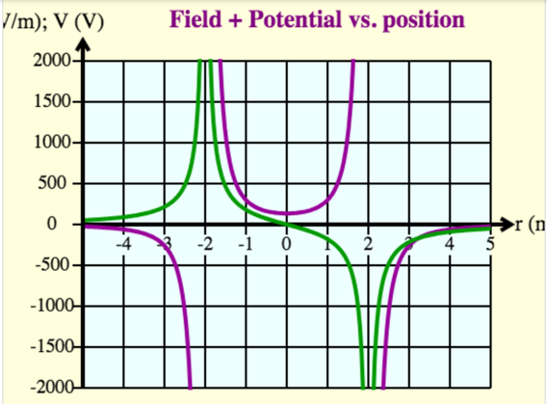

1. Left charge is negative, right charge is positive

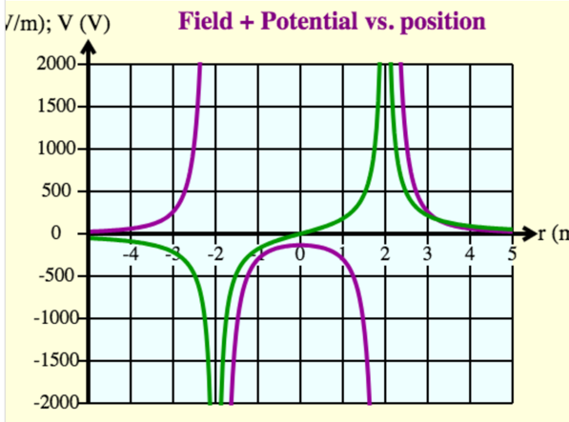

1. Connecting potential and potential energy
2. For simplicity, case 1 has particle with charge 1nC and move it to 70V equipotential line. What is change in electric potential energy? How much work do we do in this process? How much work is done by field in this process?
3. Change in electric potential energy:

U = qV

U = 1nC \* (70-60)

U = 1nc \* 10

U = 10nJ

1. Work done by us:

U + K + W = U + K

W = U(final) + K(final) – U(initial) – K(initial)

W = U(final) – U(initial)

W = 10nJ

1. Work done by field: (should be -10nJ due to work done by us and conservation of work)

W = F \* d \* cos(theta)

W = qE \* d \* cos(theta)

W = q \* delta V / delta d \* d \* cos(theta)

W = 1nC \* 10V / 0.1m \* 0.1m \* cos(theta)

W = 1nC \* 10V \* cos(theta)

W = 10nJ \* cos(theta) where theta = 180 between downward force and upward displacement

W = -10nJ